**Functions**

-- **Python Functions** is a block of statements that return the specific task.

-- The idea is to put some commonly or repeatedly done tasks together and make a function so that instead of writing the same code again and again for different inputs, we can do the function calls to reuse code contained in it over and over again.

-- Some **Benefits of Using Functions**

* Increase Code Readability
* Increase Code Reusability

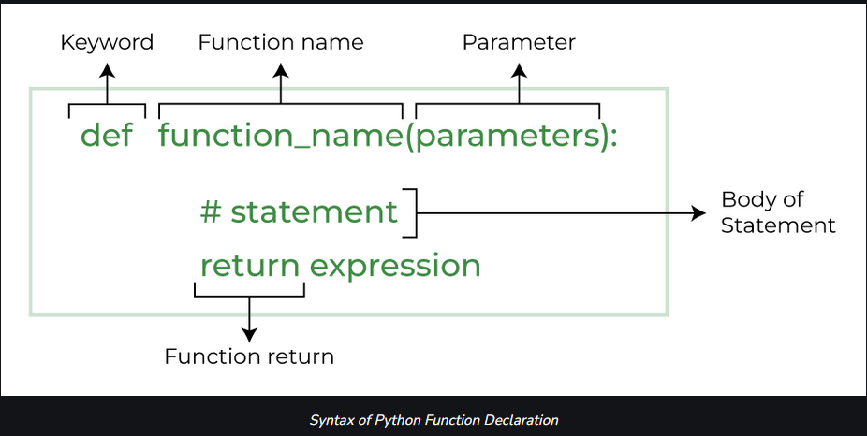

**Types of Functions in Python**

There are mainly two types of functions in Python.

* **Built-in library function:** These are standard functions in Python that are available to use.
* **User-defined function:** We can create our own functions based on our requirements

**Creating a Python Function:**

-- We can create a user-defined function in Python, using the **def** keyword. We can add any type of functionalities and properties to it as we require.

# *A simple Python function*

def *fun*():

  print("Hello World")